Here is the presentation title in bold, 14pt,

Arial (or similar), align centre

First Author¹, Presenting A. Underlined², and Third Author in Arial 12pt^{1,3}

¹ First Affiliation, From this city, And that country
² Second Affiliation, Another city, Another country
³ And the third one, all centred and in italic 10pt, City, Country

After two empty lines abstract begins in Arial (or similar) 11pt. Please do not change the page size or the margins of the page (set to 2,5 cm or 1 in) as we need space to add header and page number. Text should be justified left and right, single line spacing.

Figure 1: Conference webpage banner
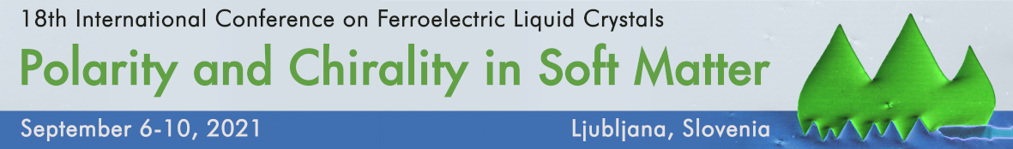
You can include illustrations and figures, as long as the whole abstract fits on one A4 page. Add references at the end of the abstract [1]. Please, export the abstract in pdf format and submit it via the online submission form, found on the conference website.

Do not forget to acknowledge funding, if your funders require it.

[1] Organising Committee, Book of Abstracts 3, 14 (2021).

